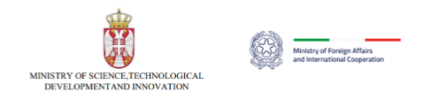

**EXECUTIVE PROGRAMME FOR SCIENTIFIC AND TECHNOLOGICAL COOPERATION**

**BETWEEN THE REPUBLIC OF SERBIA AND THE REPUBLIC OF ITALY**

**FOR THE YEARS 2025-2027**

In accordance with the article n. 8 of the Agreement on the Scientific and Technological Cooperation between the Government of the Republic of Serbia and the Government of the Republic of Italy, signed in Rome, on December 21st 2009, and entered into force on February 5th 2013, the IVSession of the Serbian-Italian Joint Commission was held in Belgrade on January 20, 2025 to examine the present state and further development of scientific and technological cooperation between the two Countries and to define the Executive Programme for the years 2025-2027.

The Serbian delegation was headed by the **Acting Assistant Minister for International Cooperation and European Integration**, **Ivana Vukašinović**, and the Italian delegation was headed by **Ambassador** of Italy to Serbia **Luca Gori**. The members of the two delegations are listed in **Annex I.** The Institutions in charge of the co-ordination of the present Executive Programme, hereinafter referred as to the “Parties”, are:

For the Serbian Party, the **Ministry of Science, Technological Development and Innovation**;

For the Italian Party, the **Directorate General for Country Promotion – Office IX** - of the Ministry of Foreign Affairs and International Cooperation

The following agenda items of the Joint Commission were adopted by the Parties:

1. Review of Scientific and Technological Cooperation between the two Countries

2. New Executive Programme

3. Schedule of of the next meetings and final provisions

**1. REVIEW OF THE SCIENTIFIC AND TECHNOLOGICAL COOPERATION BETWEEN THE TWO COUNTRIES**

The Parties have agreed to recognize the growing importance of science and technology with the respect to the economic, social and cultural relations between the two Countries. The Parties, considering the good relationships between the two Countries, placed particular emphasis on the role of international cooperation and stressed the need to further develop and promote bilateral cooperation in the field of science and technology. They also agreed to favour and extend the cooperation in international and European multilateral R&D programmes, with particular regard to the Horizon Programme of the European Union.

**2. NEW EXECUTIVE PROGRAMME**

In the period between December 13rd 2023 – February 9th 2024, a joint call for proposals was launched to collect project proposals referring to the following priority areas:

* Agriculture and Food Technology
* Information and Communication Technologies
* Energy Transition and Hydrogen-focused Research
* Basic research in Physics

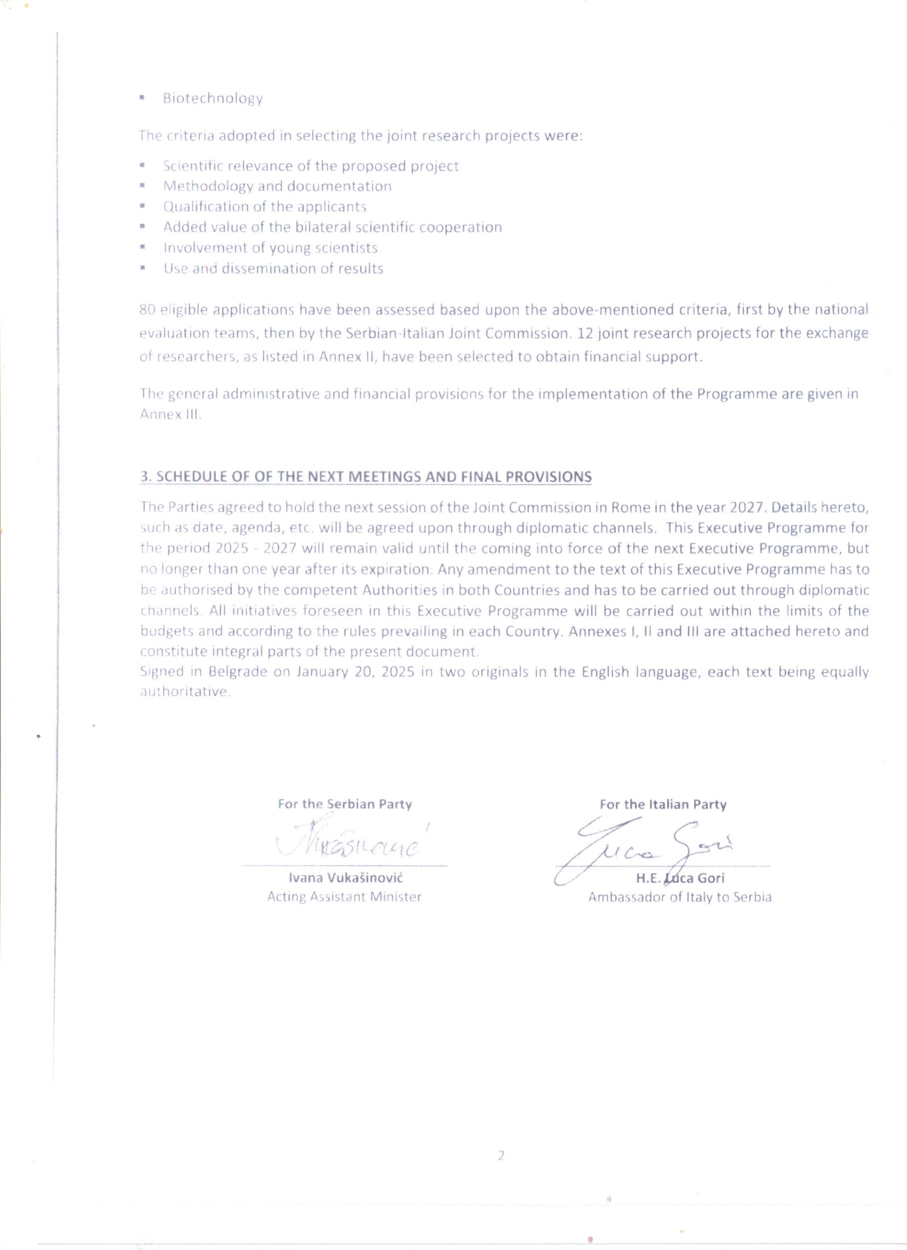

**Annex I**

**MEMBERS OF THE TWO DELEGATIONS**

|  |  |
| --- | --- |
| **SERBIAN DELEGATION** | **ITALIAN DELEGATION** |
| Ivana Vukašinović,  Acting Assistant Minister | H.E. Luca Gori  Ambassador of ltaly in Belgrade |
| Jovan Milić  Special Adviser to the Minister | Fabiana Urbani  Commercial Attaché |
| Svetlana Bogdanović  Senior Adviser | Luciano Catani  Science Attaché |

**Annex II**

**PROJECTS FOR EXCHANGE OF RESEARCHERS SELECTED WITHIN THE FRAME OF THE**

**EXECUTIVE PROGRAMME OF SCIENTIFIC AND TECHNOLOGICAL COOPERATION**

**BETWEEN THE REPUBLIC OF SERBIA AND THE ITALIAN REPUBLIC FOR THE YEARS 2025-2027**

|  |  |  |  |  |  |  |
| --- | --- | --- | --- | --- | --- | --- |
|  | **Area** | **Serbian Principal investigator** | **Serbian Institution** | **Title of the project** | **Italian  Principal Investigator** | **Italian Institution** |
| 1 | Information and communication technologies | Ðurić  Snežana | BioSense Institute, University of Novi Sad | *Development of sustainable plant- wearable sensors for on-site continuous plant monitoring toward precision agriculture* | Niko  Muenzenrieder | Libera Università di Bolzano  Faculty of Engineering |
| 2 | Information and communication technologies | Mladenovič  Goran | University of Belgrade, Faculty of Mechanical Engineering | *Data-integration and digital twins for advanced addictive manufacturing* | Mercuri  Francesco | Istituto per lo Studio dei Materiali Nanostrutturati  CNR |
| 3 | Information and communication technologies | Pešovic  Uros | Faculty of technical sciences Cacak, University of Kragujevac | *Smartphone-based motion tracking system for the self- assessment of motor capacity* | Picerno  Pietro | Dipartimento di Scienze Biomediche UNISS |
| 4 | Agriculture and Food Technology | Šojić Merkulov  Danijela | University of Novi Sad Faculty of Sciences | *Utilizing nanotechnology and sustainable approaches for environmental remediation in the agri-food systems* | Vione  Davide Vittorio | UNITO |
| 5 | Agriculture and Food Technology | Vidović  Marija | IMGGE (Institute of Molecular Genetics and Genetic Engineering), | *Identifying crucial players in desiccation tolerance: a step towards improving crop drought resistance* | Masi  Antonio | DAFNAE – Dip. di Agronomia, Animali, Alimenti, Risorse  UNIPD |
| 6 | Basic research in physics | Stavrić  Srdjan | Vinca Institute of Nuclear Sciences - National Institute of the Republic | *Van der Waals heterostructures for altermagnetic spintronics* | Barone  Paolo | SPIN - CNR |
| 7 | Basic research in physics | Keta  Otilija, Dimitrije | Vinca Institute of Nuclear Sciences - National Institute of the Republic | *ENCHANTING- EnhanCing radiotHerApy effectiveNess by TargetING cancer resilience* | Manti  Lorenzo | Dip. Fisica "E. Pancini"  UNINA |
| 8 | Biotechnology | Radić  Danka | Institute of General and Physical Chemistry | *Pollution talks: sensors equipped plants for heavy metal pollution detection and bioremediation* | Gabano  Elisabetta | Dip. per lo Sviluppo Sostenibile e la Transizione Ecologica  UNIUPO |
| 9 | Biotechnology | Filipović  Saša R | Institute for Medical Research, University of Belgrade. Department: | *Development of a personalised target- driven technique for noninvasive enhancement of cognitive functions using transcranial magnetic stimulation* | Belardinelli  Paolo | CIMeC – UNITN |
| 10 | Energy transition and hydrogen- related research | Papović  Snežana | Faculty of Sciences, University of Novi Sad | *Towards safer energy storage: next- generation lithium-ion battery electrolytes* | Di Pietro  Maria Enrica | Dipa. di Chimica, Materiali e Ingegneria Chimica "G. Natta" POLIMI |
| 11 | Energy transition and hydrogen- related research | Marinković  Zlatica | Faculty of Electronic Engineering Niš | *Ultra-low power consumption Microsystems-based electrical switches for the energy transition in the frame of the Internet of Things, 6G and Future Networks* | Iannacci  Jacopo | Center for Sensors and Devices (SD) Fondazione Bruno Kessler (FBK) |
| 12 | Energy transition and hydrogen- related research | Dojcilović  Radovan | Vinca Institute of Nuclear Sciences, National Institute of the Republic of Serbia | *Probing ultrafast dynamics of charge carriers in perovskite- inspired Ag- Bi-I nanomaterials* | Cinquanta  Eugenio Luigi | Istituto di Fotonica e Nanotecnologie CNR |

**Annex III**

**GENERAL ADMINISTRATIVE AND FINANCIAL PROVISIONS**

The bilateral projects to be financed for the exchange of researchers within the present Programme are exclusively those mentioned in Annex II.

For each project, 2 short-term stays (up to 7 days each) and 1 long-term stay (up to 21 days) may be yearly funded on both sides within the limits of the available annual resources of each Party. Such stays might be also carried on in one solution not exceeding 35 days per year.

The researchers will be entitled to the exchange only if they hold the Serbian nationality for those travelling to Italy and the Italian nationality (or any EU nationality and resident in Italy) for those travelling to Serbia.

The costs of accommodation and living shall be covered by the receiving Party, while the costs of international travel up to the host institution shall be covered by the sending Party.

Accident and health insurance coverage (excluding already existing and chronic diseases) shall be provided on both sides by the researchers’ sending institution.

At the end of each year, the Serbian researchers and the Italian researchers have to submit a report on the activities carried out during their visits to both the Serbian Ministry of Education, Science and Technological Development and the Italian Ministry of Foreign Affairs and International Cooperation. The reports must be signed by both Serbian and Italian project coordinators involved in the joint research project. Funding for the next year will not be granted if the coordinators fail to submit their progress reports.

**VISIT OF SERBIAN RESEARCHERS TRAVELLING TO ITALY**

The Serbian Party will pay the international travel expenses to researchers holding Serbian nationality. The supplied tickets will be the most economical ones available for the trip, economy class (2nd class) flight/train/ride. Any additional cost shall be borne by the researchers.

**STAY OF SERBIAN RESEARCHERS IN ITALY**

The date of the visit should be agreed between the visiting researchers and the host Italian coordinator. Serbian researchers may obtain the authorization for the visit from the Italian Ministry of Foreign Affairs and International Cooperation only by submitting application form online at the following link: <https://ricercatori.esteri.it>. An invitation letter from the host Italian Institution, signed by the Italian coordinator, must be uploaded to the online application. The Italian Ministry of Foreign Affairs and International Cooperation, after checking the application for accuracy, if necessary funds are available, will authorize the visit and pay for the visit allowance. The Italian Ministry of Foreign Affairs and International Cooperation will timely inform the Italian Embassy in Belgrade, the Serbian researcher and the Italian project coordinator. The application must be submitted **at least 35 days before the scheduled visit**.

Any cancellation of the visit by the researcher, unless due to serious and valid reasons, might prevent the hosting Party from accepting further applications for subsequent missions.

For short term stays (up to 7 days), the Italian Party shall provide a contribution of 99,00 € per day. For long term stays (up to 21 days), the Italian Party shall provide a contribution of 99,00 € per day from day 1 to day 10 as well as 38,00 € per day from day 11 to day 21. Further 38,00 € per day shall be provided from day 22 to day 35 in case of bundled stays. The above-mentioned amounts shall be paid to the Serbian researchers entirely in one instalment at their arrival in Italy. Serbian researchers will receive their grants at the nearest Provincial Treasury (local branch of the Banca d’Italia).

**VISIT OF ITALIAN RESEARCHERS TRAVELLING TO SERBIA**

Italian researchers travelling to Serbia for a research stay are required to submit the online application to the Unit for Scientific and Technological Cooperation – Directorate General for Country Promotion (Economy, Culture and Science) of the Italian Ministry of Foreign Affairs and International Cooperation at

<https://ricercatori.esteri.it>

Applications must be submitted to the Italian Ministry of Foreign Affairs and International Cooperation **no later than 35 days prior to the foreseen date of departure**. Details of the above mentioned rules and the online application are available on the web site of the Ministry of Foreign Affairs and International

Cooperation at <https://www.esteri.it/it/diplomazia-culturale-e-diplomazia-scientifica/cooperscientificatecnologica/programmiesecutivi/mobilitaricercatori/mobilitaricercatoriitaliani/>

The Italian Party will pay the international travel expenses to researchers holding Italian nationality (or any EU nationality and resident in Italy). The supplied tickets will be the most economical ones available for the trip. Any additional cost shall be borne by the researcher.

**STAY OF ITALIAN RESEARCHERS IN SERBIA**

The Serbian Party will finance, yearly, for each project listed in Annex 2, 2 short-term stays (up to 7 days each) and 1 long term stay (up to 21 days). For short term stays, the Serbian Party shall provide a contribution of 90,00 € per day. For long term stays the Serbian Party shall provide a contribution of 90,00 € per day, from day 1 to day 7, as well as 38,00 € per day from day 8 to day 21. Further 38,00 € per day shall be provided from day 22 to day 35 in case of bundled stays.

The above-mentioned amounts will be paid, converted into RSD, to the host institution for Italian researchers entirely in one instalment at their arrival in Serbia. Italian researchers will receive their grants from the host institution in Serbia.

**REPORTS ON THE PROJECT**

At the end of each year the Serbian and the Italian coordinators will jointly report on the progress of their project. Funding for the next year will not be granted if the coordinators fail to submit their progress reports.

The Serbian coordinators have to submit the reports in .pdf to the Serbian Ministry of Science, Technological Development and Innovation.

The Italian coordinators have to submit the reports in .pdf to the Italian Ministry of Foreign Affairs and International cooperation (*DGSP – Office IX:* [*ricercatori.italiani@esteri.it*](mailto:ricercatori.italiani@esteri.it))